Flower Estates Civic Association

Minutes of the Annual General Meeting

November 16th, 2021

The meeting was called to order by Nancy Wagner at 6:35 PM in the Holy Trinity Lutheran Church Gym.

The PowerPoint slides that were presented during this meeting are included in these minutes, starting after the bottom of the text portion of the minutes.

2020 Financial Report and YTD 2021 Financial Report: Debra explained the Full Year 2020 and Year-To-Date 2021 financial reports (as shown on Slides #3 and #4), emphasizing that the FECA board is very careful with the residents’ dues money. She noted that the current balance is $45,273 (as shown on Slide #5). Nancy noted that Debra has done a great job as treasurer.

Flower Estates Park: Nancy said that the board filled the pothole and added rock to the park driveway, that the board repaired the wooden fence and the “fort”, and that the board is planning to add picnic tables (as shown on Slide #6).

Azalea Gardens: Nancy talked about the drainage issues (runoff flowing onto N. Dogwood lots). Coordination with the Parish has resulted in all drainage being in place (according to the developer), all of the fencing between their development and the residential lots is up, and planting will begin next week and be completed 5-8 weeks from now (as shown on Slide #7).

Estates of Watercross no cut buffer: Nancy noted that the northern border of this development is just south of Flower Estates South and across Flower Bayou from a portion of Flower Estates North, and that its westward extent is about five Begonia Dr. houses west of the intersection of Begonia Dr. and S. Marigold. She explained that the enforcement of the 100-foot no-cut buffer behind Flower Estates South is up to any resident of Flower Estates. She noted that she had sent letters to Watercross residents who own strips of this buffer behind Flower Estates lots explaining enforcement of the no-cut stipulation.

Marigold and Azalea Signs: Dr. Dan said that he took down the Azalea sign and that the Marigold sign blew down during Ida, and he said that the signs will be put back up soon.

Bylaws: Nancy said that they are in the process of being revised. She said that a draft will be finalized by the board and sent out on the EIS for residents’ review.

Flower Bayou: Nancy said that the Parish Public Works Department is coordinating with the state’s Scenic Rivers office to get the trees that fell across the bayou removed (but that there are 200 miles of waterways in the parish that have to be cleared after Ida). She suggested calling Donna O’Dell (the engineer with the parish who is the point of contact for this work) about the status of this work (see slide 9).

Timber Branch II aka Vieux Carre: Nancy said that a development consisting of 415 houses plus commercial facilities is proposed between Bricker Rd. and Bootlegger Rd. She noted that the Coalition for Responsible Zoning strongly feels that this development is a bad idea, and that the coalition opposes it. She noted that, during the Oct. 19th, 2021 Planning and Zoning Commission meeting, rezonings for the first 5 zoning cases within this development were denied, but the developer is appealing the denials to be heard at the December 2nd, 2021 Parish Council meeting. She noted that more info is available via Covingtonneighbors.org.

Burning of yard debris: Nancy said that we should be considerate of others when we burn, especially those with health problems – each of us should do our best to burn hot and to minimize smoke.

“Medline” Update: Nancy said that the rezoning appeal is in the appeals court – she figures that we have a decent chance of winning there, and if so the case would go back to the circuit court. She noted that the Medline distribution center is being built in Hammond, but we are still appealing the rezoning for the Covington site where it was originally proposed to be built because something even worse could be built there (see Slide #10).

Costco: Over 51% of Flower Estates lot owners have signed the amendment agreement. Nancy said that 100% of the 47 commercial restricted properties must also sign in order to enable Costco to build in the Brookfield development just west of Buffalo Wild Wings (all but 6 have signed as of now). She noted the concessions that Costco has made that are favorable to Flower Estates, including the sound barrier wall and prohibition of cut-throughs (see Slide #11).

Thanks to 2021 board members and election of 2022 board: Motion to elect all members shown on Slide #12 was made by Dr. Dan, seconded, all in favor.

Thanks to current board members (including those leaving) and to Glenn Shaefer for providing the audio/visual equipment: (see Slide #13)

New Business: A suggestion was made to do the block captain idea again; Nancy suggested E-mailing this idea to the new board after the first of the year.

Nancy said that the next board meeting is Dec 1st to elect board officers.

Meeting adjourned at 7:18 PM by Nancy Wagner.

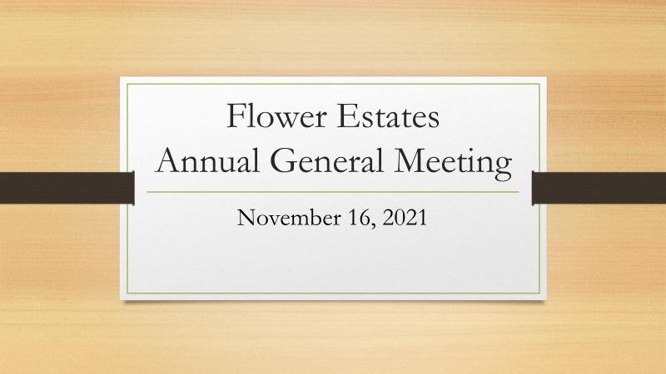
Slide #1

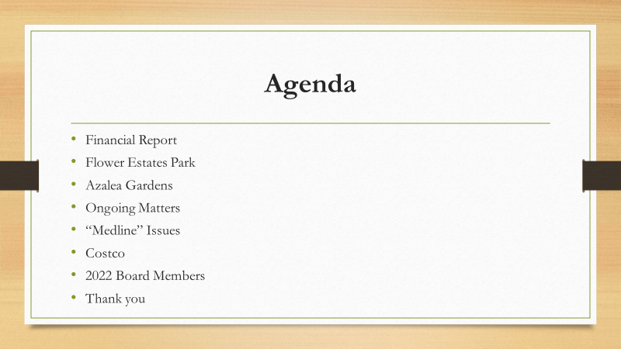
Slide #2
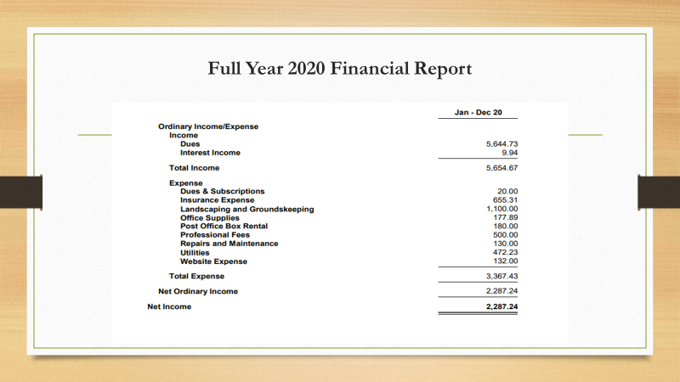
Slide #3

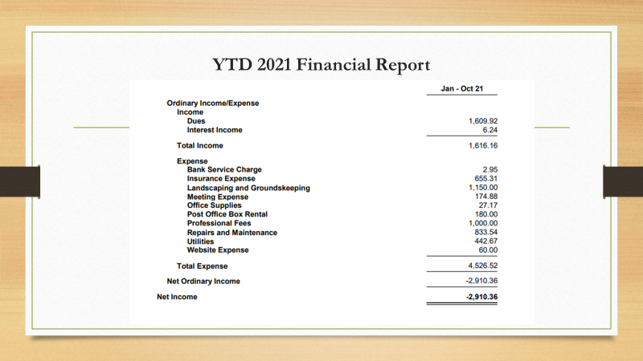
Slide #4
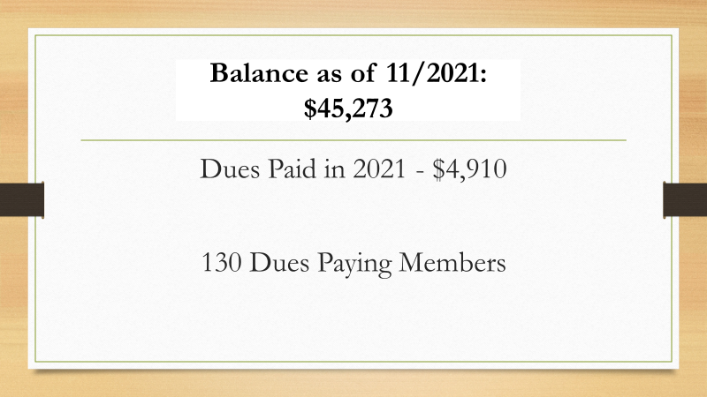
Slide #5

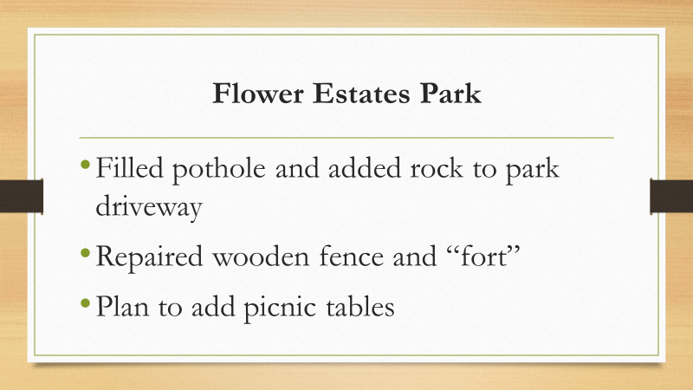
Slide #6
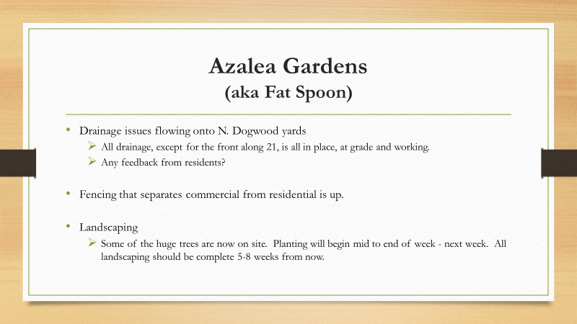
Slide #7

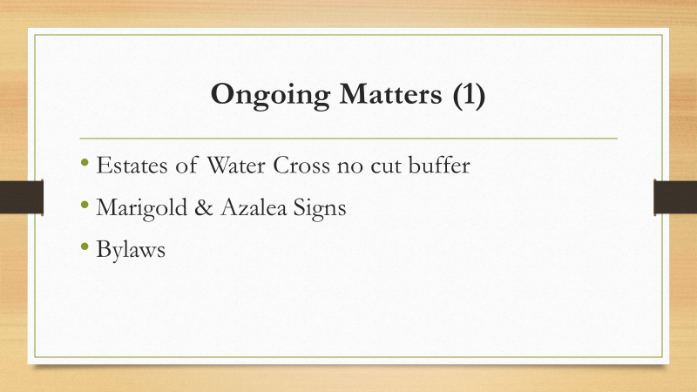
Slide #8

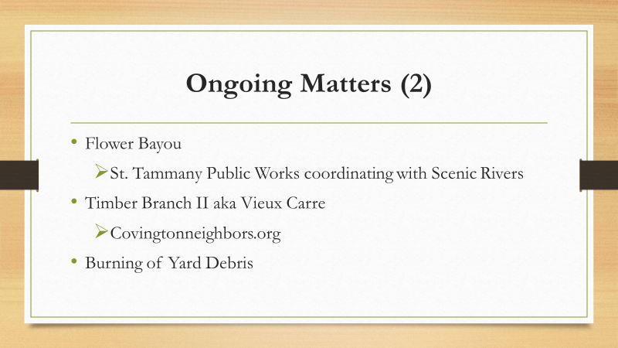
Slide #9

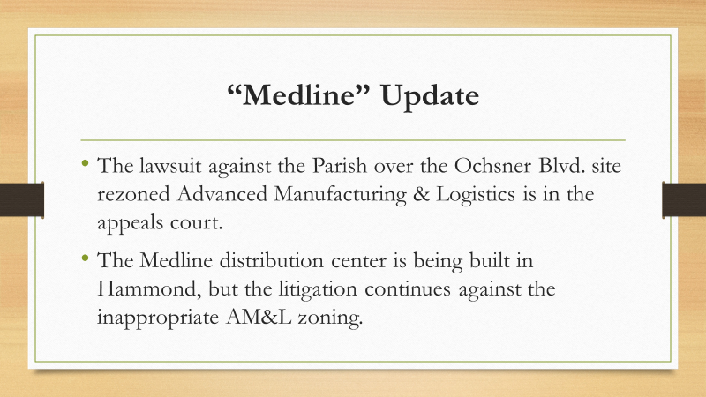
Slide #10

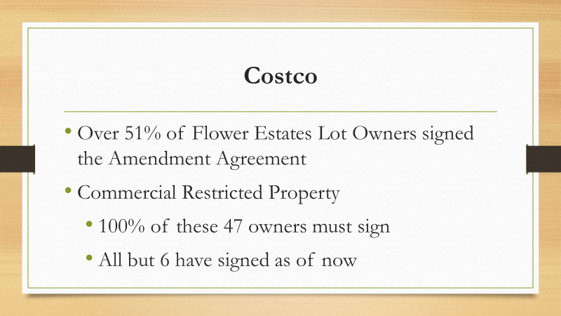
Slide #11

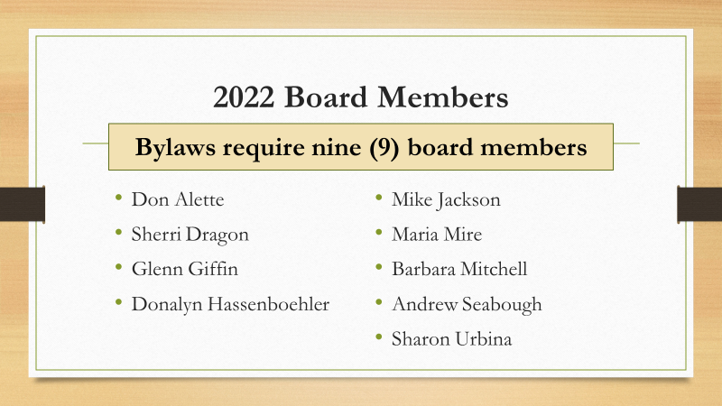
Slide #12

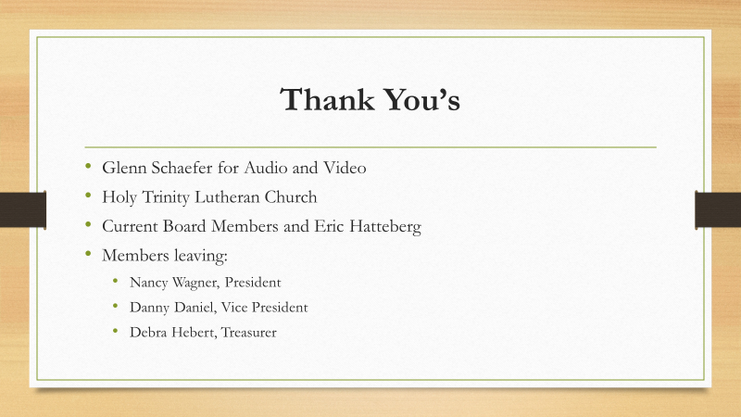
Slide #13

